just, finished, thought, continue, grasp that, second, possibility, has to say, well





Finished, thought, just, continue, grasp that, second, possibility, has to say, well

1. Both
2. Both
3. About
4. Both
5. Both
6. Both

Guess missing word

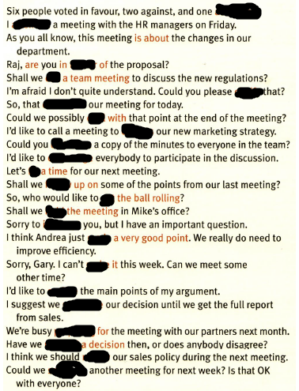

Withheld, called, favour, run, clarify, concludes, deal, discuss/go through, distribute/circulate, encourage/engage, set/fix/determine, follow up, get, run/hold, interrupt/disturb, made, make, outline/underline, postpone, preparing/gearing up for, taken, discuss/go over, schedule/call